TEAM ID : PNT2022TMID20093

CLOUD OBJECT STORAGE

BUCKETS

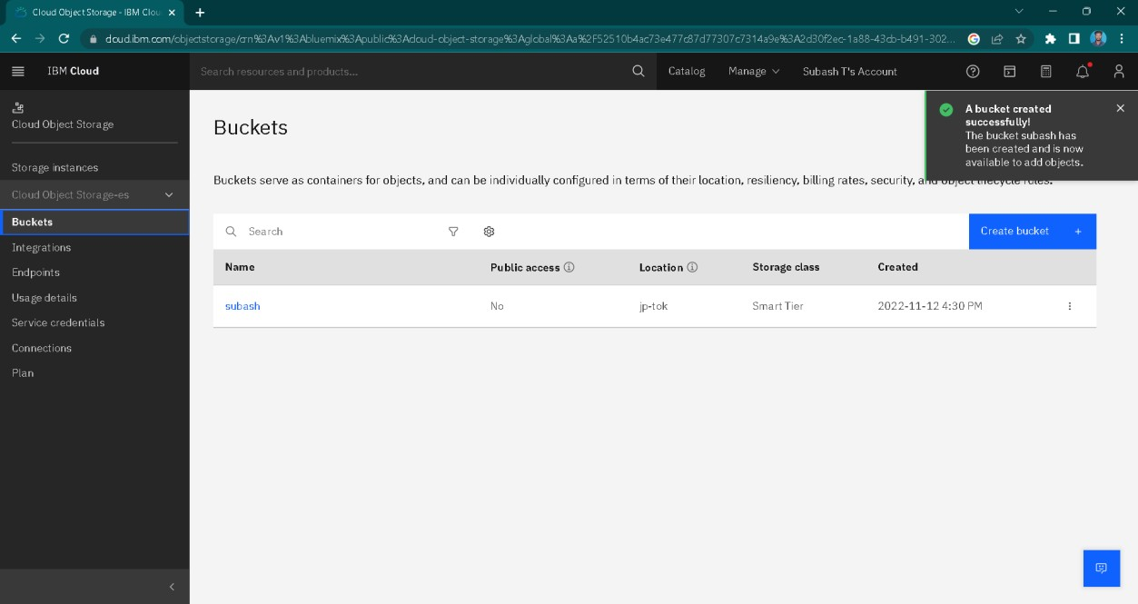

ENDPOINTS

